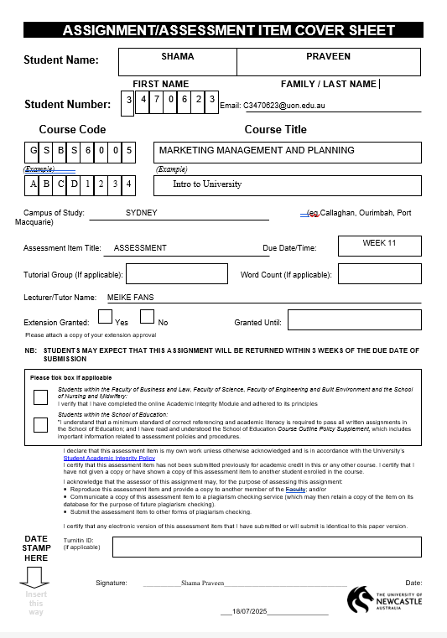

Contents
1. Introduction 3
2. The Current Situation Analysis 3
3. SMART marketing objectives 5
4. Target Market Selection 7
5. Positioning Strategy 8
6. Marketing mix approaches 9
6.1 Product Strategy 10
6.2 Pricing strategy 10
6.3 Promotions Strategy 11
6.4 Distribution Strategy (Place) 11
CONCLUSION 14
REFERENCE 15

1. Introduction

The exponential development of the electric vehicle (EV) technology is transitioning the world into an entirely different state of transportation with Australia becoming an evolving market as government incentives have become more financially available, fuel prices have been rising, and consumer mindsets regarding sustainability have changed (Australian Government, 2023; International Energy Agency [IEA], 2023). Tesla, the worldwide leader in EV development and self-driving technology, started servicing Australia, opening its verticalized manufacturing, state-of-the-art software, and high-end image (Tesla, Inc., 2024) officially in 2014 and achieved a healthy early mover advantage in the country; despite a relative lack of owned retail locations, the company has firmly established its headquarters in Sydney and, unlike in Australia, operates dozens of its own service units in major cities and locations across the country (Tesla, Inc., 2024). Nevertheless, the market is getting competitive and other players like BYD, Hyundai and Polestar are gaining market share because their products are cheaper and more functional (Statista, 2024). Tesla Australia observed a 12% decrease in market share to 42 % by 2024 (Roy Morgan Research, 2024; Electric Vehicle Council, 2024). The numbers indicate the problematic nature of competitive advantage, fixes in the infrastructure, and adapting to new customer demands. The report is a continuation of a previous situation and segmentation analysis which presents an understanding of the overall marketing scheme to suit the strategic renewal of Tesla in the Australian context. It sets out well articulated SMART objectives, suggested customer hit-list methods based on solid segmentation intelligence, laid down multi-prong positioning format and suggested comprehensive marketing mix direction. The strategy leverages both academic theory and industry statistics of the recent past to not only be current but also feasible and capable of positioning itself in line with the sustainable mobility vision of Tesla in the future of Australia (Kotler et al., 2019).

2. The Current Situation Analysis

In Australia, Tesla is the leader in the market of electric vehicles (EV) with a large market share of 42% in early 2024. Its models Model 3 and Model Y are the most innovative, efficient and are known to be safe. The fact that Tesla enjoys an early-mover advantage in terms of EV technology, as well as the vertically integrated structure has established the standards in energy efficiency and self-driving features.

Despite these strengths, Tesla is developing several pressure zones. Tesla rivals like BYD and MG manufacture cheaper models, which are eroding their prices and making them more affordable to a wider market. Further, the current notable deficiency in the infrastructure namely the scarcity of service centre and extending maintenance queue is undermining customer satisfaction especially in the regional location.

The consumer expectations are also changing. Although Tesla has been an early adopter sought after by people who loved the tech and design and who saw it as a forward-looking experience, newer users who purchase EVs, particularly their families and institutional fleets, choose duty, dependability, and affordability. Moreover, the CEO of Tesla has been the subject of popular scrutiny, which has affected brand recognition, and it is critical to localize the brand narrative of Tesla to Australian customers.

Overall, the contemporary position of Tesla can be characterized by such aspects:

Innovation leadership but loss of share to increased price-based competition
Flaws in service and repair facilities that can drain the customer dry
Untapped potential on the family and fleet buyer segment

Dissatisfaction with the positioning of brand messages to appeal to broader population groups and defuse scandal around the CEO

This is an opportunity and a crisis to create a more detailed marketing program that would serve to regulate the opportunities in service accessibility, enhance the accessibility of the segments, and improve on the competitive advantage that Tesla has.

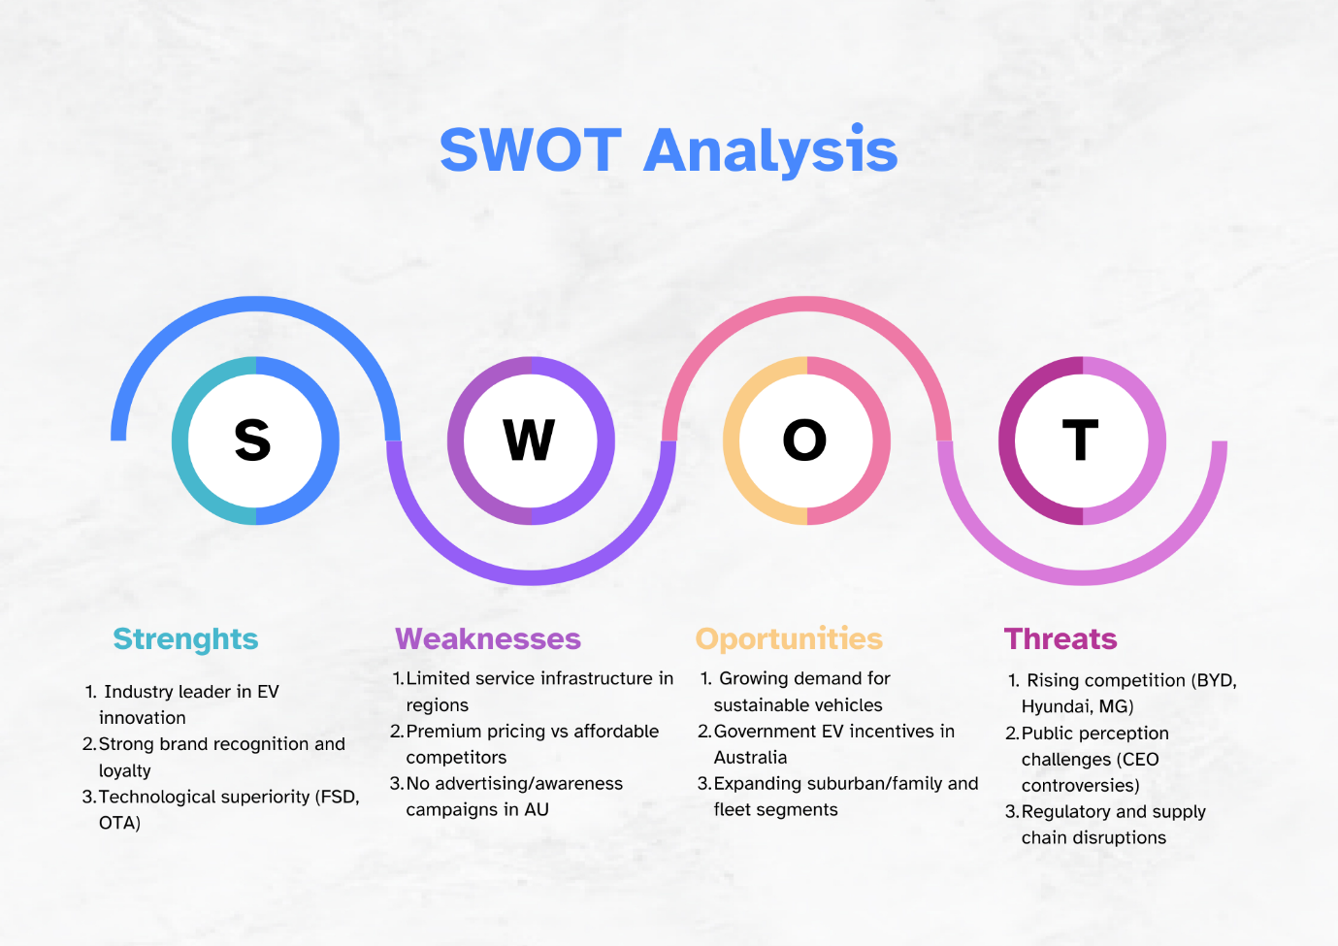

3. SMART marketing objectives

According to the SWOT analysis and the dynamic of the EV market, the 12-month marketing plan of Tesla will be based on three SMART objectives that meet both around growth strategy (through the Ansoff Matrix) and positioning with regards to the brand as innovative, sustainable, and customer-experience-driven (Kotler et al., 2019). The aims are made to improve the value proposition of Tesla, fill the gaps in infrastructure and services and assist the company to gain the competitive edge due to customer satisfaction and segmental growth.

Objective 1: Increasing Service Infrastructure in underserved regions
By the end of 2025, Tesla will build-in 12 new service shops in regional Queensland, Tasmania, Western Australia, and out metro NSW to drive down the average level of wait time to less than 7 days starting at 16 days. This enhances the marketing penetration and customer retention strategy of Tesla as pain points in post purchase are directly addressed. Since the ability to maintain premium brand equity relies on customer experience and after sales service, customer accessibility increases trust and loyalty (Kotler et al., 2019). Additionally, the program supports Tesla differentiation strategy; the company has recently focused on serving such customers as families and fleets, making it easier to own a Tesla (Roy Morgan Research, 2024).

Objective 2: Accelerating Market Share by Incentivising Sales Expansion
Tesla has planned to sell 25 percent more units by Q4 2025 and hence market share rises to 50 percent up to 42 percent. This will be facilitated by tapping on the government EV subsidies and improved delivery logistics as well as new product bundling. This plan depicts the market penetration and product development aspects of Ansoff, in which the aim of growth is to increase volume in the existing markets with product differencing (Ansoff, 1957). This is possible thanks to the Total Cost of Ownership (TCO) advantage that makes Tesla more expensive against competitors nevertheless (Clean Energy Finance Corporation, 2023). The goal will also help Tesla to position itself as a value-oriented leader, acting in the direction of affordability without sacrificing innovation.

Objective 3: Targeted Expansion in new Segments through Families and Fleets
By June 2026, Tesla will obtain 5 new fleet partners and increase family purchasing of the Model Y and 3 by 35 percent using both targeted promotions and pricing based on ESG. This is in line with market development and diversification of market segments so that Tesla can tap into the underexploited B2B and suburban family market (Kotler et al., 2019). High efficiency / low maintenance Fleet and institutional purchasers want vehicles with those characteristics most of which is what the Tesla brand is about. The goal accentuates the perception of Tesla as a mission-based, scalable productivity tool to sustainability-minded companies (Tesla, Inc., 2024).

Collectively, such purposes deploy quantifiable KPIs and portray seamless strategic orientation. Not only do each of them justify tactical gains, but they also strengthen Tesla positioning pillars, which include innovative leadership, sustainable excellence and consumer trust. The development pathways merge infrastructure enhancement, price-accessibility stories, and demographic growth to present a sustainable foundation that can be competitive over the long-term perspective of the Australian EV world.

Objective | Specific Action | Measurable Outcome | Strategic Justification | Deadline
1 | Open 12 service centres in underserved regions | Avg. wait time < 7 days (from 16) | Improves customer experience; supports retention & brand trust | Dec 2025
2 | Promote Model 3/Y with gov’t incentives and affordability campaigns | 25% sales growth; market share ↑ to 50% | Supports market penetration & TCO value narrative | Q4 2025
3 | Target fleets/families with pricing, promo bundles | 5 fleet deals; 35% family buyer growth | Enables segment diversification and ESG alignment | June 2026

4. Target Market Selection

The marketing approach of Tesla in Australia should shift considering the changing demands of customers, regulatory trends, and competition. According to STP effects (Segmentation, Targeting, and Positioning) (Kotler et al., 2019), three main groups of customers, based on a former segmentation research, were identified with references to demographic, psychographic, and behaviour indicators. Not only are these groups short-term sources of revenue potential but also have the ability of long-term brand affiliation with the innovation and sustainability goals of Tesla.

Target market 1: Tech-savvy Urban Professional (Target in the City)
Target audience: 25–45-year-olds Millennials and Gen X’s Urban professionals located in Sydney, Melbourne, Brisbane
Psychographic: Tech lovers, innovation admirers, adopters Preference Profile Psychographic: Tech lovers, innovation embracers, early adopters
Behavioural: Is responsive to the experience of digital, wants a value autopilot, OTA updates

Such consumers are in alignment with the brand DNA of Tesla: they are digital natives, who regard technology as the lifestyle amplifier. They tend to be two-career households professionals, and they value conveniences, innovative features, and being environmentally responsible. Such segmentation is amenable to experiential marketing and new product development. Because they tend to be opinion leaders within their spheres of influence, these people are linked to positive word-of-mouth, as well as brand virality, which enhances the reach of Tesla.
This part contributes to the differentiation and the premium positioning of Tesla, whereby the brand can possess the pricing power, further cultivate the advocacy, and technological affinity (Kotler et al., 2019). Software upgrades, automaticity, and simplistic design must be highlighted in the marketing communications process.

Target Market 2: Eco-friendly Families
Demographic: mid-high income (35 50) families, residents of suburban Australia
Psychographic: Concerned about the environment, economical, safety oriented
Behavioural: Long-term value seeking, rebate as well as sustainability interested

This segment is becoming increasingly pertinent with EVs having become the popular trend. Parents are becoming interested in finding secure, trustworthy, and environmentally friendly means of transportation. Tesla is also becoming a competitive option due to the government subsidies and savings on running costs (Clean Energy Finance Corporation, 2023). The Model Y has a 5-star ANCAP safety rating and has a lot of space, making it fit to serve a family.

Low total cost of ownership reduced environmental impact, and design friendly to the family are qualities that should be marketed. Tesla is not only a status symbol in this situation but a sustainable lifestyle investment. The brand will be able to be aspirational and pragmatic, combining a high value offering with long-term financial and environmental savings.

Target market 3: Corporate and Government J-Fleets
Demographic: Government agency buyers, universities and corporate institutional buyers
Psychographic: decision-makers ROI and ESG
Behavioural: is interested in all cost of ownership, emissions reduction, and reliability

This segment is interested in scalable EV options which would be used to support Environmental, Social and Governance (ESG) objectives as well as cutting the operating expenses. The segment is a strategic expansion of Tesla in the market development strategy (Ansoff, 1957) since the company is taking a step further into the B2B markets.

The top priorities of fleet managers include the battery run, easy maintenance, and suitable charging. Its long-term use as a fleet vehicle is a good idea due to Autopilot, management via an app and a better TCO. The most important levers include tailoring of prices, bulk programs of purchases, as well as priority servicing.

5. Positioning Strategy

As the needs of each target segment are changing, Tesla will have to change its positioning to appeal to the wider range of Australian consumers. The rest of the positioning strategy should convey the brand values of Tesla that are innovation, sustainability, high performance, and tailor its message to match the segment requirements.

City Tech-Savvy Elites: Sell Tesla is the most high-tech and futuristic electric transportation innovation, highlighting such advanced technologies as Full Self-Driving (FSD), OTA software updates, attractively minimalistic design and intelligent connectivity. Main communication: Drive the Future: Intelligent, Electric, Effortless.

Eco-conscience families: Cast Tesla as a safe, and sustainable family car that saves the user money in the long term. Emphasise the 5-star ANCAP safety ratings, space, low running cost and good environmental features. Major message: Smart to Your Family. Right to Planet.”

Corporate and Government Fleets: Highlight the total cost of ownership (TCO) which makes Tesla one of the cheapest to own, the tax benefits, and suitability in meeting the goals set out by ESG. Enhance the leadership position of the company in battery range and charging infrastructure and minimize the downtime of the fleet operations. Major headline: Powering Purpose: Electric Mobility in the sustainable enterprise.

This multifaceted positioning framework keeps Tesla topical and special in the mind of the different classes of Australian buyers. There will be coherent themes of what a brand is about innovation, trust, sustainability, etc., which will unite campaigns whereas each messaging will personalise value propositions to different priorities.

Segment | Positioning Theme | Core Message | Value Proposition
Urban Tech-Savvy | Futuristic, Connected, Smart | “Drive the Future: Intelligent, Electric, Effortless” | State-of-the-art features, seamless updates, minimalist design
Eco-Conscious Families | Safe, Green, Economical | “Smart for Your Family. Right for the Planet.” | High safety, low cost of ownership, sustainable living
Corporate/Gov Fleets | Efficient, Purposeful, Scalable | “Powering Purpose: Electric Mobility for Sustainable Enterprise” | ESG alignment, low operational costs, fleet analytics

6. Marketing mix approaches

In the bid to implement the above marketing goals and segmentation plan, Tesla should formulate a coherent and evidence-based 4Ps (Product, Price, Promotion, Place) strategy. This is because they will be associated with the following improvements to accommodate emerging customer needs and preferences but also improving the competitive status of Tesla in the Australian electric vehicle (EV) market.

6.1 Product Strategy
The product strategy of Tesla will have to correspond to the Five Product Levels by Kotler namely core benefit, basic product, expected product, augmented product, and potential product (Kotler et al., 2019). The fundamental value is sustainable and economically effective transport to Australian consumers; the base product is a technologically progressive EV; the projected product is range, safety, and design; and augmented products are Autopilot, over-the-air upgrades, and Tesla mobile app (Tesla, 2024). Potential product of Tesla is the future FSD development and compatibility with AI and renewable ecosystems (Tesla, 2024).

Recommendations:

Product variants: launch a low-cost version of Model 3 (<$600,000 AUD after subsidy) in order to attract middle income households and first-time EV purchasers.
Localized Features: Product features tailored to Australia (e.g. UV glass, increased AC, GPS for local charger etc.).
Bundled Services: Sell the TeslaCare packages (annual maintenance + service visits on wheels) to further improve the after sales reliability and perceived risk.

6.2 Pricing strategy

Tesla should strike a balance between its high-end brand concept and pricing to be based on Total Cost of Ownership (TCO) theory. CEFC (2023) estimated that Tesla EV costs approximately cent 0.04 compared to approximately cent 0.15 when using an internal combustion engine (ICE) vehicle. TCO comprises fuel savings, maintenance savings; tax breaks - all of which are becoming more important in price-conscious families and fleet-operators.

Recommendations:
Model | Target Segment | Approx. Price (AUD) | TCO/km
Model 3 Base | Families | $58,000 | $0.04
Model Y Long Range | Fleet/Tech Users | $72,000 | $0.045
Model S | Premium | $130,000+ | $0.05

Fleet & Govt. Incentives: Provide customized pricing & Bulk Discount on Corporate/H Goverment Fleets

Flexible Financing- Offer novated leasing, buy back guarantees, laugher-based trade-in bonuses.

6.3 Promotions Strategy
As a part of promotion strategy Tesla should combine AIDA (Attention-Interest-Desire-Action) model and Integrated marketing communications (IMC) model as to ensure integrity between messages translated across various platforms.

Recommendations:

Segment-Specific Campaigns:

Tech-savvy users: YouTube review of tech products, VR test drive simulation.
Families: Radio sponsored safety centred campaigns, parenting blogs, cinema ads.
Fleets: Whitepapers on ESG-compliant issues, LinkedIn webinars, and business magazines.

Data-Driven Promotions:
The interest in Tesla grew in Australia by 30% YoY (Roy Morgan, 2024) and, by relying on Google Trends and social listening, the campaign can be targeted.
The use of referrals to drive sales has shown to generate up to an 18 percent higher conversion among Tesla sales in previous quarters (Tesla, 2023).

Loyalty & Community:
Community test drives, Local EV expos, and mall-based Tesla Pop-Up stores.
Tesla should expand the family and fleet partners levels of referral rewards.

6.4 Distribution Strategy (Place)
Tesla needs to consider its digital-first approach through Omnichannel Distribution Strategy and strike a balance between the digital and physical to minimize the customer friction and create a wider rate, particularly in underserved markets.

Recommendations:

We need to extend Physical Network:
Introduce 12 service centres throughout 2025 such as Canberra, Cairns and Hobart.
Using Kotler Channel Design Decision Process, make dealerless model conform to regional requirements.

Improvement of Online Platform
Enhance portals and configurators that are client-specific to fleets.
Install live chat, financing calculators, and real-time availability of the chargers.

Vehicle Mobile & Supercharger:
The 2025-2026 targets are to increase the capacity of mobile service units by 70 percent.
Collaborating with third- party networks (EVIE, Chargefox) upgrade new regional charging facilities.

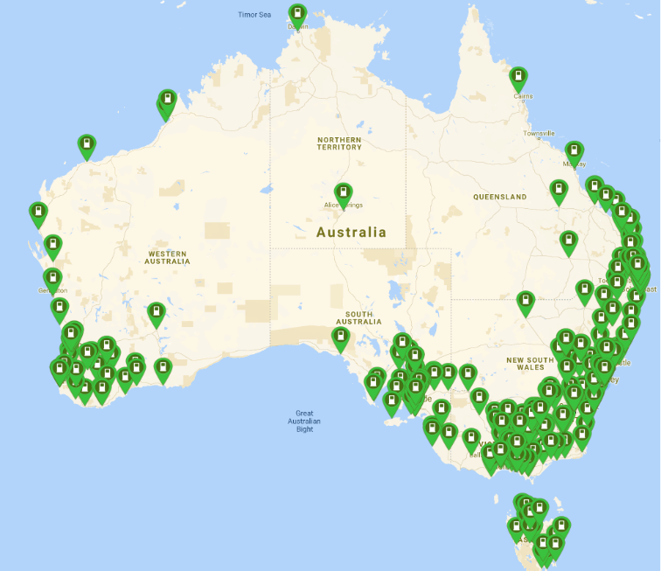
Fig 1

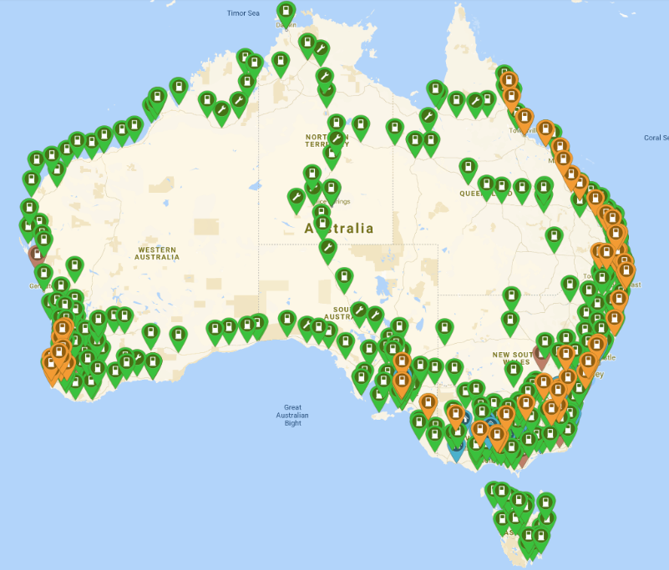
Fig 2

Fig 1 and 2 demonstrate the division of current service and charging infrastructure of the company Tesla in Australia and the general EV charging situation within the nation. As shown in figure 1, Supercharger stations owned by Tesla are more concentrated along eastern seaboard in cities such as Sydney, Melbourne and Brisbane. Although this network targets core metropolitan regions, the provision of service points in places like Tasmania, Northern Queensland, and Northern Territory shows a major area of weakness in terms of regional access. By comparison, Figure 2 overlays the broader EV charging network in Australia, now also including a third-party network such as Chargefox and Evie, indicating a covering that is more national in scale. This more expansive perspective indicates that there is a future possibility of Tesla prospectively building up its service centers closely with the already emerging public charging corridors especially in inland or remote underrepresented areas. Collectively, both maps illustrate the necessity of a hybrid distribution strategy: scale the proprietary infrastructure and make use of national charging development to establish trust, convenience, and coverage in all Tesla owners and especially family and fleet customers, whose service access or lack thereof is critical to their business (Electric Vehicle Council, 2024; Tesla, 2024).

Such strategic measures with regard to the 4Ps within the local context of consumer handling, infrastructure requirements, and competitive standards create the integrated marketing background, which enhances the relevance of its brand in the Australian EV marketplace and its growth.

SMART Objective | Marketing Mix Element | Strategic Link
Reduce service wait times (<7 days nationally) | Distribution | Open 12 service centers + expand mobile service fleet
Increase market share from 42% → 50% | Price, Promotion | Entry-level pricing, fleet discounts, multi-channel awareness campaigns
Grow family & fleet segment by 35% | Product, Promotion | Localized features, fleet offers, family-focused messaging
Strengthen tech image for urban professionals | Product, Positioning | Highlight Autopilot, FSD, software updates in all messaging

CONCLUSION

Overall, this Tesla Australia marketing plan has critically examined the evolving environment of the electric vehicle (EV) market and outlines a concise sequence of strategic steps within the context of supporting the market leadership of the company. Through the sound knowledge base of the market situation, emerging consumer bases, and competitive stressors, the plan finds the possibilities of the SMART objectives that are not only aligned with the innovation-driven DNA of Tesla but also points to the appropriate marketing principle, namely the Ansoff Matrix as the growth planning tool and Total Cost of Ownership (TCO) as the positioning resource.

Segmentation and positioning model makes Tesla relatively relevant to the group of urban residents that are tech-savvy, eco-friendly households, and corporate/governmental fleets buyers, whereas the integrated marketing mix functions to bring this purpose to fruition through product differentiation, value pricing, and cross-channel promotion mechanisms, and superior service network dissemination systems. Alignment matrix (visual) validates the fact that every single component of marketing mix contributes directly to strategic objectives.

Finally, the strategy provides a tactical and strategic roadmap that can enable Tesla do not only regain the market share it has lost but actualize brand equity, fill the service gap and take advantage of the emerging opportunities in the emerging Australian EV market. The tips presented here will form the sound basis of decision making of Tesla local leadership that guarantees them sustainable growth, customer satisfaction, and competitive advantage.

REFERENCE

Australian Government. (2023). Electric vehicle strategy 2023. Department of Climate Change, Energy, the Environment and Water. https://www.dcceew.gov.au/energy/transport/electric-vehicles/strategy
Electric Vehicle Council. (2024). State of electric vehicles 2024. https://electricvehiclecouncil.com.au/reports/state-of-electric-vehicles-2024/
International Energy Agency. (2023). Global EV outlook 2023: Catching up with climate ambitions. https://www.iea.org/reports/global-ev-outlook-2023
Kotler, P., Keller, K. L., Goodman, M., Brady, M., & Hansen, T. (2019). Marketing management (4th European ed.). Pearson Education Limited.
Roy Morgan Research. (2024). EV buyer behaviour and brand perception in Australia.https://www.roymorgan.com/findings/ev-consumer-preferences-2024
Statista. (2024). Tesla’s market share in Australia 2021–2024. https://www.statista.com/statistics/1316054/tesla-market-share-australia/
Tesla, Inc. (2024). Impact report 2023. https://www.tesla.com/ns_videos/2023-tesla-impact-report.pdf
Ansoff, H. I. (1957). Strategies for diversification. Harvard Business Review, 35(5), 113–124.
Clean Energy Finance Corporation. (2023). Comparing the total cost of ownership: EVs vs ICE vehicles. https://www.cefc.com.au/media/media-release/ev-tco-comparison/
Kotler, P., Keller, K. L., Goodman, M., Brady, M., & Hansen, T. (2019). Marketing management (4th European ed.). Pearson Education.
Roy Morgan Research. (2024). EV buyer behaviour and brand perception in Australia. https://www.roymorgan.com/findings/ev-consumer-preferences-2024
Tesla, Inc. (2024). Impact Report 2023. https://www.tesla.com/ns_videos/2023-tesla-impact-report.pdf
Ansoff, H. I. (1957). Strategies for diversification. Harvard Business Review, 35(5), 113–124.
Clean Energy Finance Corporation. (2023). Comparing the total cost of ownership: EVs vs ICE vehicles. https://www.cefc.com.au/media/media-release/ev-tco-comparison/
Kotler, P., Keller, K. L., Goodman, M., Brady, M., & Hansen, T. (2019). Marketing management (4th European ed.). Pearson Education.
Roy Morgan Research. (2024). EV buyer behaviour and brand perception in Australia. https://www.roymorgan.com/findings/ev-consumer-preferences-2024
Tesla, Inc. (2024). Impact Report 2023. https://www.tesla.com/ns_videos/2023-tesla-impact-report.pdf
CEFC. (2023). Comparing the total cost of ownership: EVs vs ICE vehicles. https://www.cefc.com.au
Kotler, P., Keller, K. L., Goodman, M., Brady, M., & Hansen, T. (2019). Marketing management (4th ed.). Pearson.
Roy Morgan. (2024). EV buyer behaviour and brand perception in Australia. https://www.roymorgan.com
Tesla. (2023). Impact Report. https://www.tesla.com/ns_videos/2023-tesla-impact-report.pdf
Tesla. (2024). Find us – Tesla Service Centres. https://www.tesla.com/findus/list/services/Australia
Tesla, Inc. (2023). Australia vehicle pricing and features. https://www.tesla.com/en_au
Statista. (2024). Tesla’s market share in Australia 2021–2024. https://www.statista.com/statistics/1316054/tesla-market-share-australia/
Roy Morgan Research. (2024). EV buyer behaviour and brand perception in Australia. https://www.roymorgan.com/findings/ev-consumer-preferences-2024
Kotler, P., Keller, K. L., Goodman, M., Brady, M., & Hansen, T. (2019). Marketing management (4th European ed.). Pearson Education Limited.
Electric Vehicle Council. (2024). State of electric vehicles 2024. https://electricvehiclecouncil.com.au/reports/state-of-electric-vehicles-2024/
Tesla. (2024). Find Us – Service centers and superchargers. https://www.tesla.com/findus/list/services/Australia
Clean Energy Finance Corporation. (2023). Comparing the total cost of ownership: EVs vs ICE vehicles. https://www.cefc.com.au/media/media-release/ev-tco-comparison/

